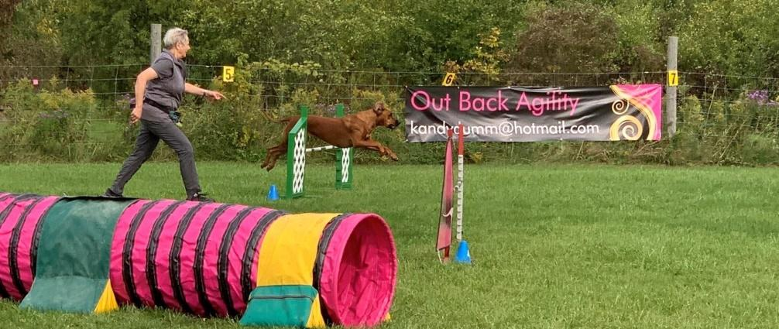
Mark the date
Sunday September 25th
RRCEC Activity Day –Agility – Racing

Hope to also include an Introduction to Rally Obedience – NOT confirmed yet

Join us for introductions to these sports – a chance to learn, try them out, fun and encouragement from all participants!
AGILITY

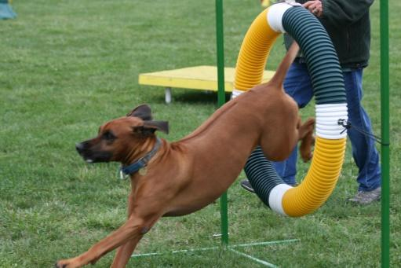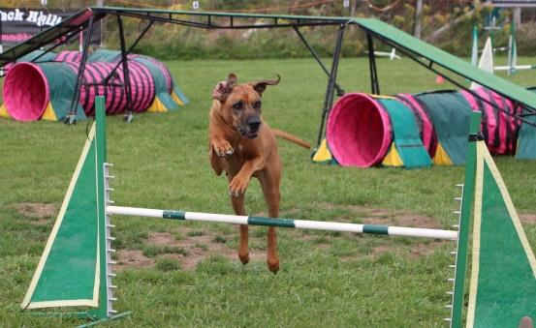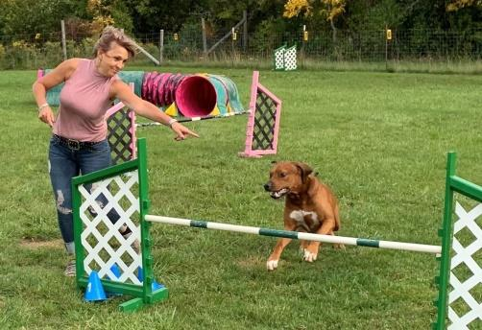
RACING

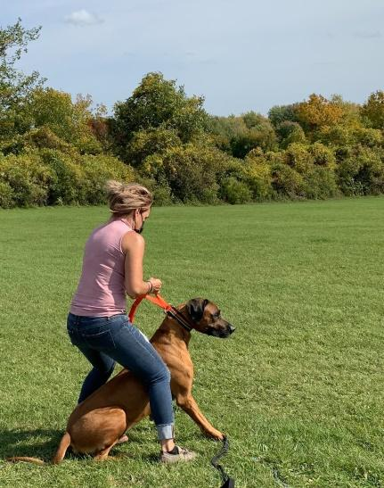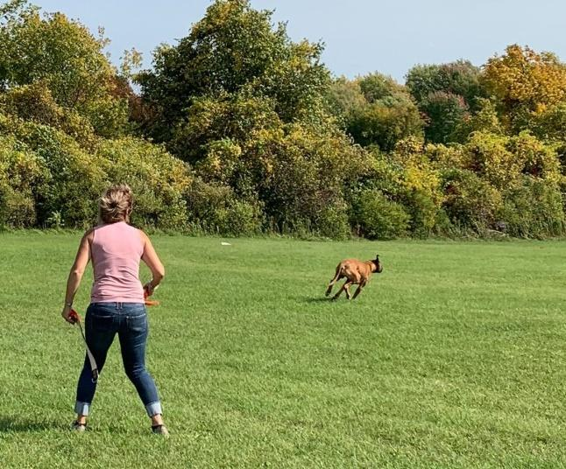

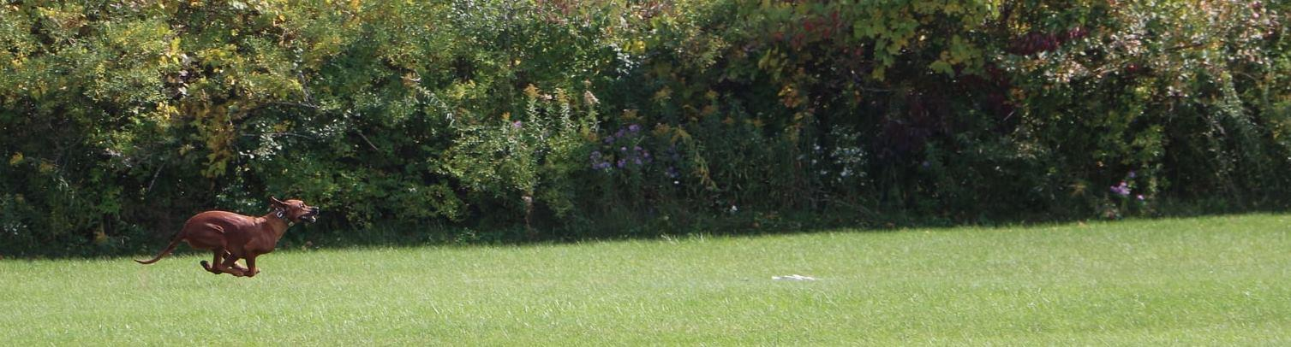

Time: 10.30 - 12.30 Agility (Two rings operating simultaneously)
12.30 – 1.30 Potluck – Lunch (Bring your own & something to share)
Coffee and water will be provided.
1.30 – 3.00 Racing

Location: OutBack Agility & Dog Sports
5809 Marine Station Road
Iroquois, Ontario

Cost: $10.00 per dog(members) $15.00/dog(non-members)
RSVP: (Diana) skyridge03@outlook.com
E-transfer: beckettj007@outlook.com
Password: dogsports

You will have the opportunity to participate in all activities. Please identify your priority for the morning sessions: Agility or Intro. to Rally O.

Full details and directions will be provided to participants.
**This is a fully fenced, secure location.
All dogs must be on leash at all times. Poop & scoop please.

